Project Design Phase-II
Technology Stack (Architecture & Stack)

Date | 20 February 2026
Team ID | LTVIP2026TMIDS40712
Project Name | Exploratory-Analysis-Of-RainFall-Data-In-India-For-Agriculture
Maximum Marks | 4 Marks

Technical Architecture:
The Deliverable shall include the architectural diagram as below and the information as per the table1 & table 2
Example: Order processing during pandemics for offline mode
Reference: https://developer.ibm.com/patterns/ai-powered-backend-system-for-order-processing-during-pandemics/
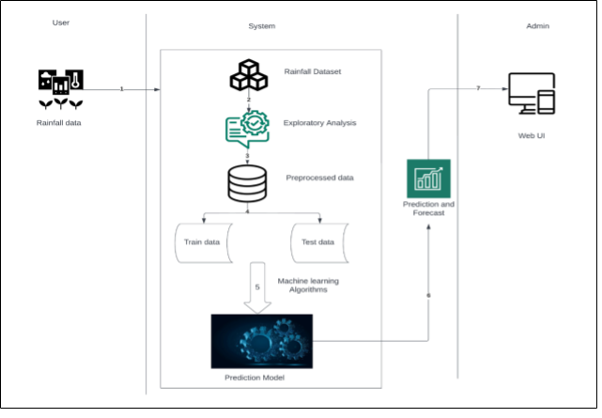

S.No | Characteristics | Description | Technology
1. | Open-Source Frameworks | Backend Framework, CSS Styling framework, Relational Database | PyJWT, Flask, IBM Cloud DB
2. | Security Implementations | Request authentication using JWT Tokens | HS-256, Encryptions, SSL Certs
3. | Scalable Architecture | Support for Multiple Sample prediction using Excel File | Pandas, Numpy
4. | Availability | Availability is increased by Distributed Servers in  Cloud VPS | IBM Cloud Hosting
5. | Performance | The application is expected to handle multiple predictions per second | Load Balancers, Distributed Servers
Table-1 : Components & Technologies:
S.No | Component | Description | Technology
1. | User Interface | How user interacts with application e.g. Web UI, Mobile App, Chatbot etc. | HTML, CSS, JavaScript / Angular Js /  React Js etc.
2. | Application Logic-1 | Logic for a process in the application | Java / Python
3. | Application Logic-2 | Logic for a process in the application | IBM Watson STT service
4. | Application Logic-3 | Logic for a process in the application | IBM Watson Assistant
5. | Database | Data Type, Configurations etc. | MySQL, NoSQL, etc.
6. | Cloud Database | Database Service on Cloud | IBM DB2, IBM Cloudant etc.
Table-2: Application Characteristics:

